CS3002 Information Security
Assignment 2 (Test Report)

Wireshark
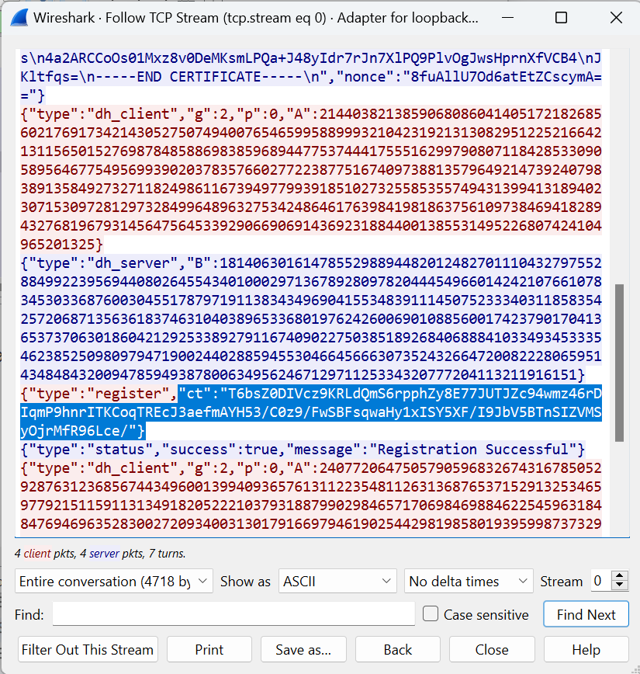 display filter: tcp.port == 9999
Invalid certificate test
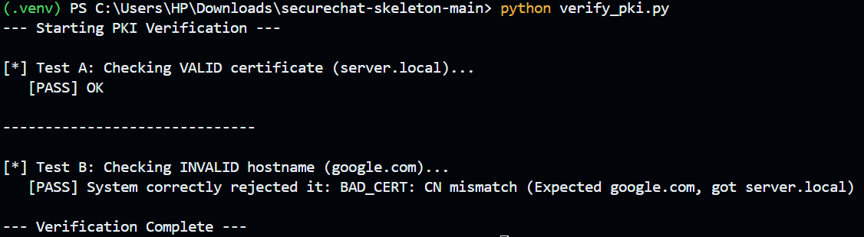

Tamper and replay attacks
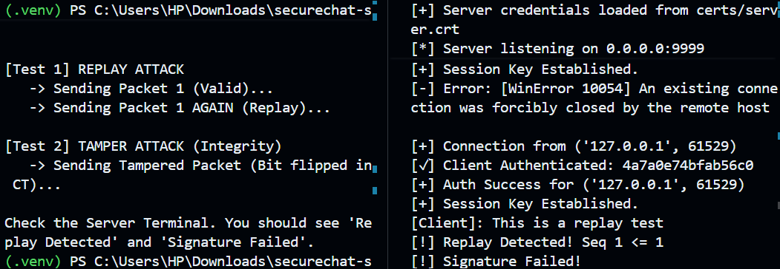
Non-repudiation
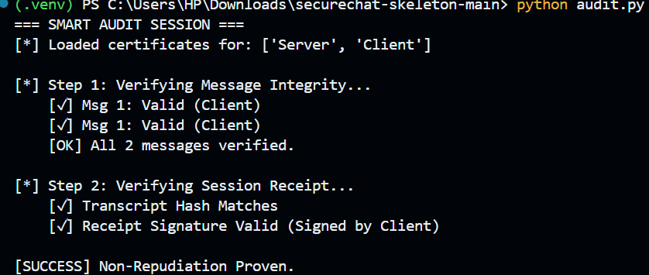
After editing one character